**JIRA Test case to create new story**

**Step1:** Load application url

<https://api-training.atlassian.net/>

**Step2:** Enter your email [hari.radhakrishnan@testleaf.com](mailto:hari.radhakrishnan@testleaf.com) and click on Continue

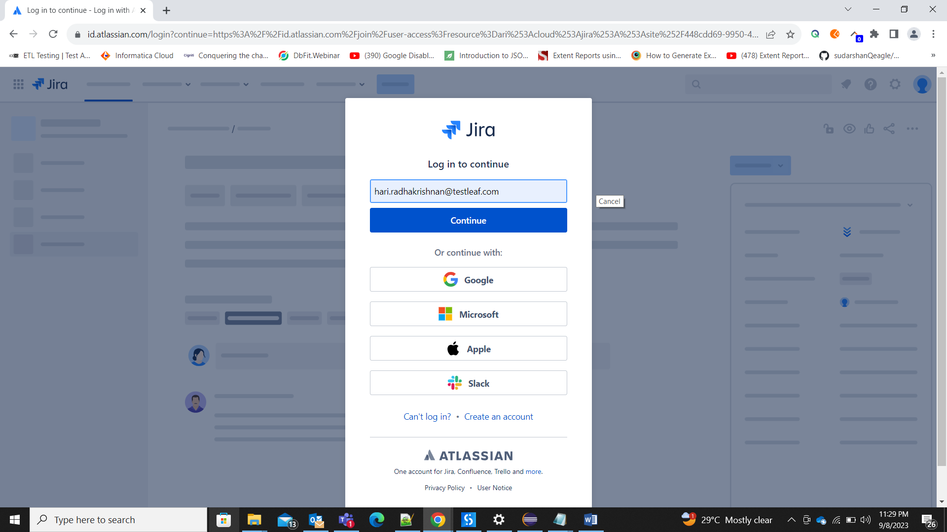

**Step3:** Enter password “India@123” and click Log in

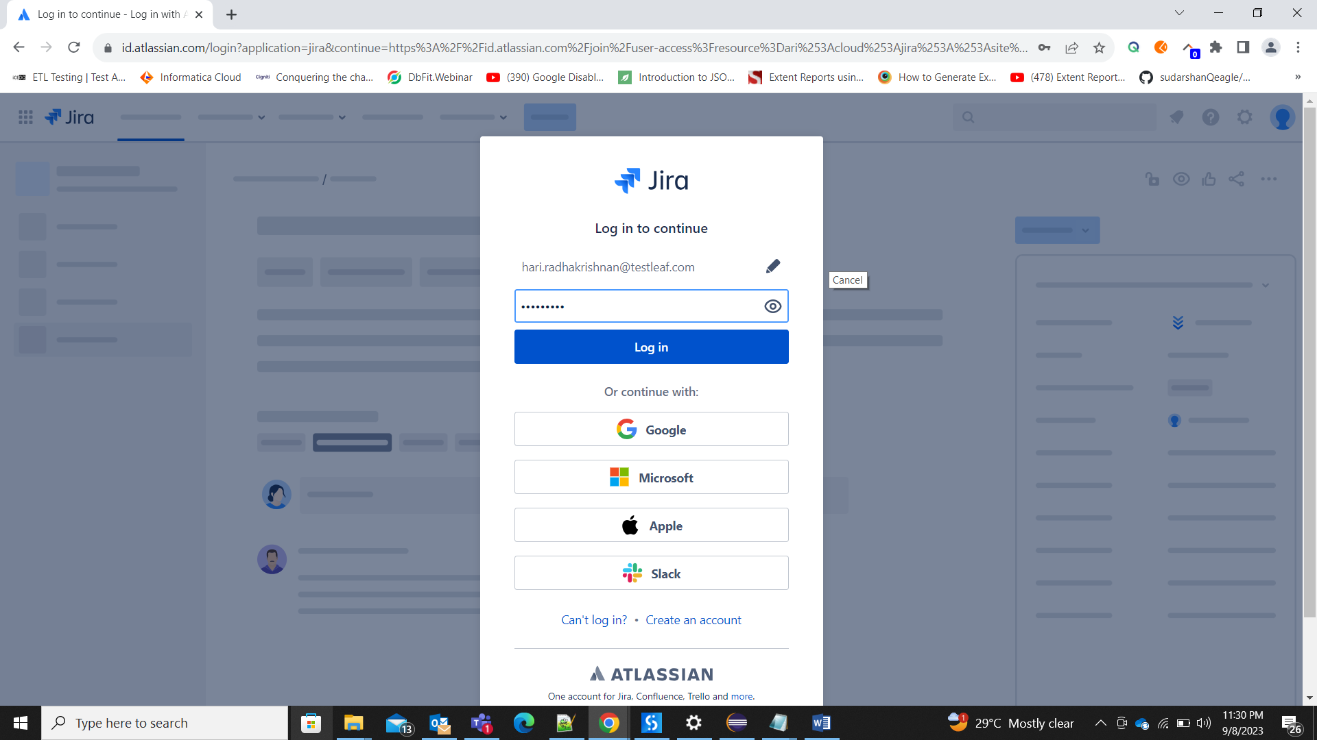

**Step4:** Select SDET-5 project

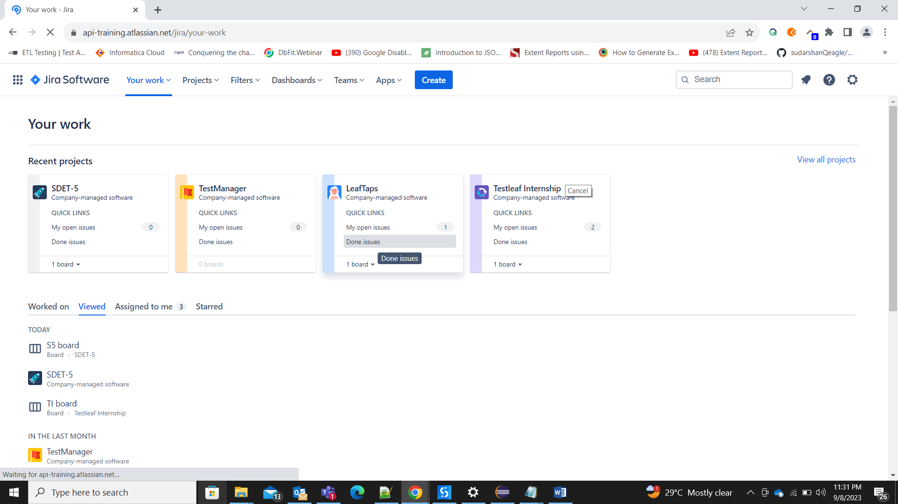

**Step6:** Click on Create button

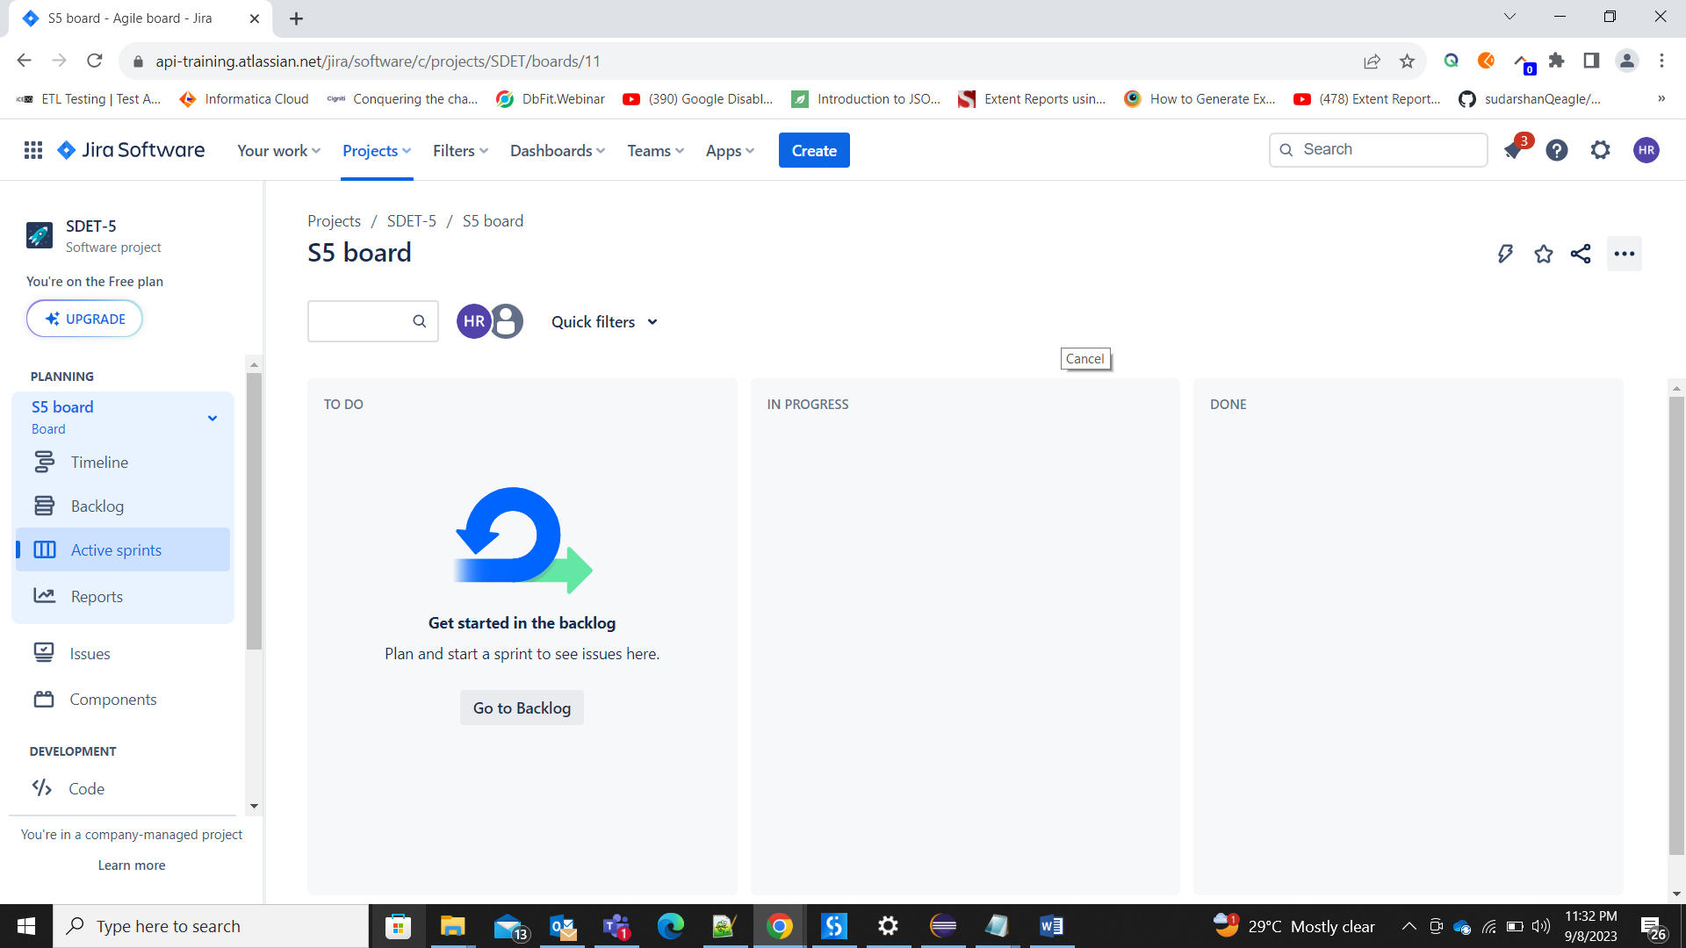

**Step7:** Enter Summary which is mandatory

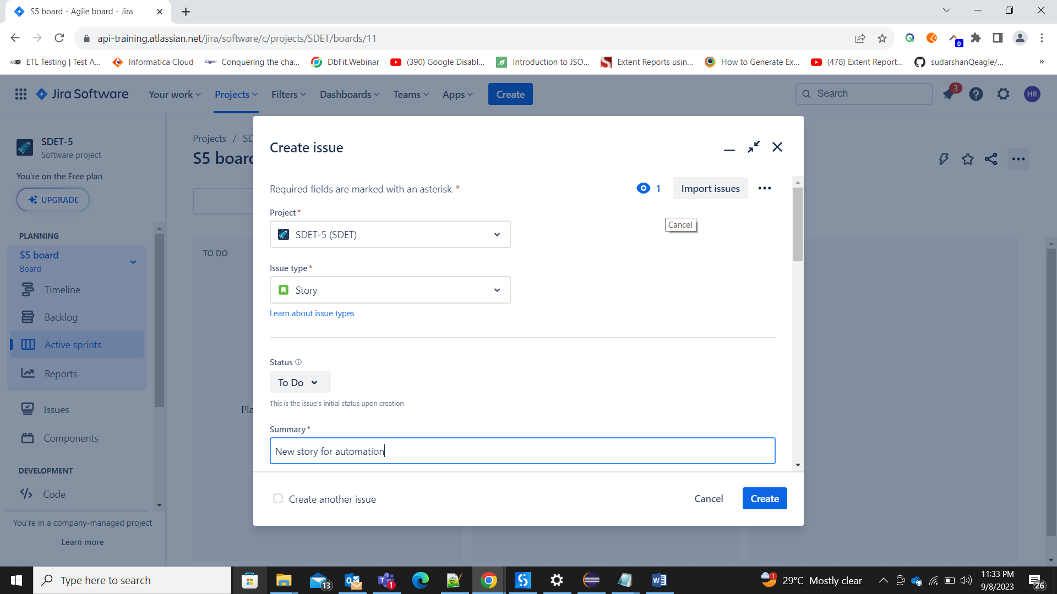

**Step8:** Click on Create button

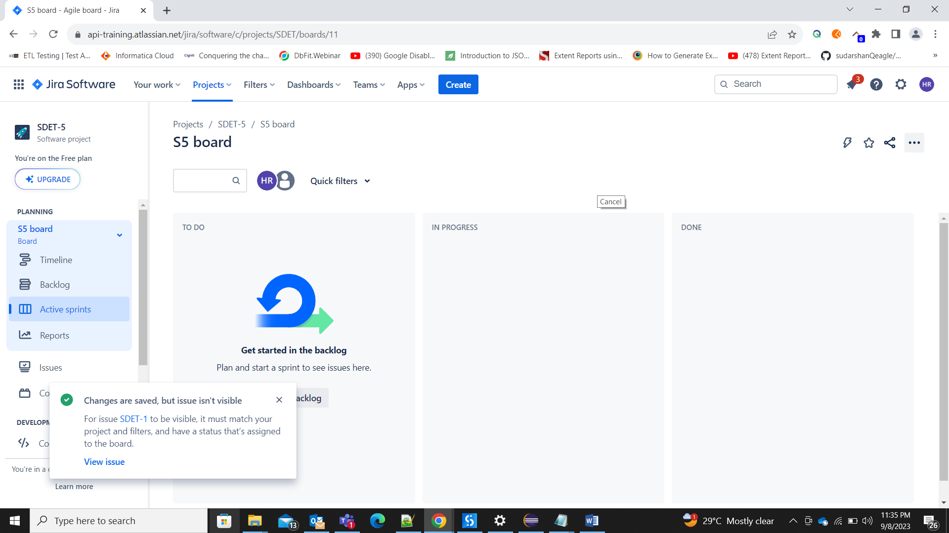

**Step9:** Click on Backlog on the left panel

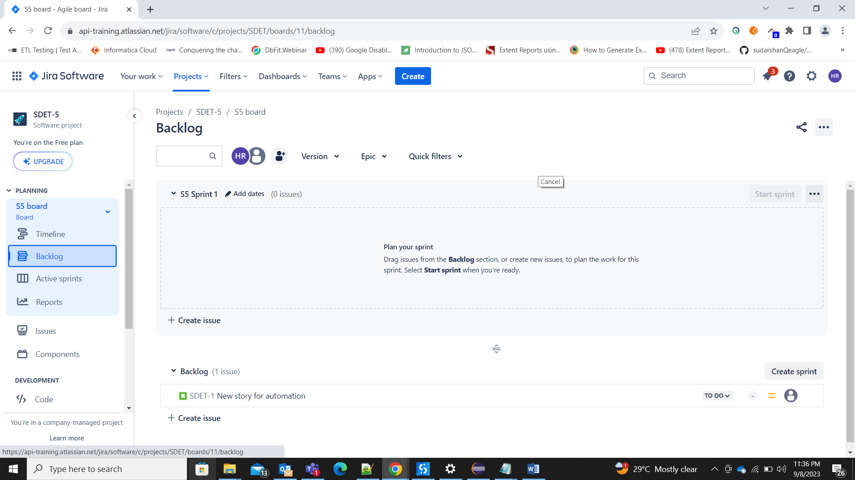

**Step10:** Search for the story we created in the search field and verify the newly created story

